Experiment 1: Efficiency Vs. Solar Panel Angle

**Purpose**

The purpose of this experiment was to test how the angle of solar panels affects their efficiency. This is useful information to know for the final design, because the way we attach the solar panel to the car will have some strategy behind it. The solar panel has to be placed in a position that allows the optimal amount of light into the solar panel to be able to have the most amount of power available to run. The independent variables are the angles of the solar panels since that is what is being modified, while the dependent variable is power produced by the solar panel as it is being measured.

Materials used for this experiment are …

* Solar Panels
* Digital Multimeter (DMM)
* 100 Ohm Resistor
* Breadboard
* Protractor
* Alligator clips
* Jumper wires

**Procedure for Experiment:**

The first step is to gather all of the materials listed above. The next step is to set up a circuit that runs the solar panel through a breadboard connected 100 ohm resistor. That resistor could then be connected to the digital multimeter to measure the voltage going through the solar panel. (Figure 1). The next step is to place the circuit in a bright spot in the sun. Use a protractor to position the solar panels at the given angles in degrees; 0, 5,15,30,35,40,60,75,90 Make sure the panels face the same direction throughout all trials. Measure the voltages using the multimeter. Repeat these steps until all 3 solar panels have one trial in all the angles. (24 total trials)

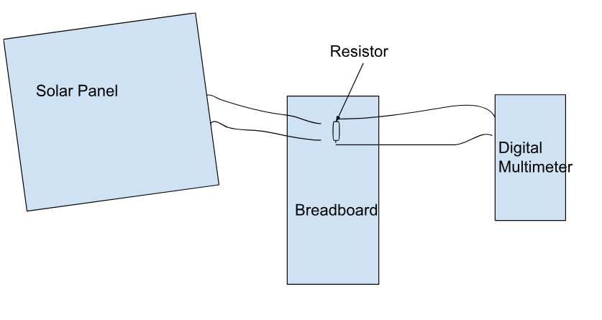

**Figure 1**

**Data of Experiment**

| **Angle in Relation to Light Source (deg)** | **Panel 1: Measured Load Voltage V1 (V)** | **Panel 2: Measured Load Voltage V2 (V)** | **Panel 3: Measured Load Voltage V3 (V)** |
| --- | --- | --- | --- |
| **0** | **13.81** | **7.06** | **3.95** |
| **5** | **13.90** | **7.06** | **4.16** |
| **15** | **13.87** | **7.04** | **4.43** |
| **30** | **13.37** | **7.02** | **3.61** |
| **35** | **13.45** | **6.88** | **3.23** |
| **40** | **12.75** | **6.91** | **3.18** |
| **60** | **12.80** | **6.90** | **3.03** |
| **75** | **13.15** | **6.76** | **2.93** |
| **90** | **12.30** | **6.92** | **6.61** |

**Experiment MATLAB code: Gabe, Trevor, Muhammad, Mena**

%variables

r=100

w=110

e=1030

angle=[0 5 15 30 35 40 60 75 90]

%User data input

prompt1='What is the surface area of the first solar panel?(Meters Squared)';

surface_area1=input(prompt1)

prompt2='What is the surface area of the second solar panel?(Meters Squared)';

surface_area2=input(prompt2)

prompt3='What is the surface area of the third solar panel?(Meters Squared)';

surface_area3=input(prompt3)

%Power of the sun

psun1=(e*surface_area1)/w

psun2=(e*surface_area2)/w

psun3=(e*surface_area3)/w

%Volatge of panels

voltage1=[13.81 13.90 13.87 13.37 13.45 12.75 12.80 13.15 12.30]

voltage2= [7.06 7.06 7.04 7.02 6.88 6.91 6.90 6.76 6.92]

voltage3=[3.95 4.16 4.43 3.61 3.23 3.18 3.03 2.93 6.61]

%Total power created

power1=(voltage1).^2/100

power2=(voltage2).^2/100

power3=(voltage3).^2/100

% Efficiency. blue is eff1, red is eff2, yellow is eff3

eff1=(power1/psun1)*100

eff2=(power2/psun2)*100

eff3=(power3/psun3)*100

plot(angle,eff1,angle,eff2,angle,eff3)

%labels for graphs

xlabel('Angle of Sun Attack (Degrees)')

ylabel('Solar Panel Efficiency')

title('Angle of Sun Attack Vs Solar Panel Efficiency')

legend('Solar Panel 1','Solar Panel 2','Solar Panel 3')

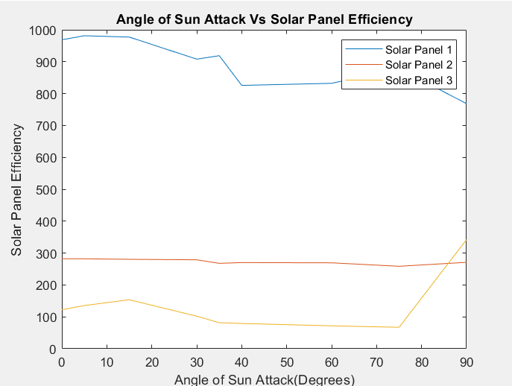

Conclusion of Experiment 1

Throughout the experiment, we found that the 1st solar panel stuck out above the rest of the solar panels in energy efficiency. We expected all of the efficiencies to decrease as the angle got closer to 90 degrees. It appears that the outcome we expected only occurred in the 1st and 2nd solar panels. The 3rd solar panel turned out to have an outlier that produced an increasing solar panel efficiency. Overall, it appears that 5- 15 degrees appears to be the optimal angle to capture the most amount of sunlight. This data is useful for the final project since we now have an idea on what solar panel could work the best, as well as we got an idea of what angle to position the solar panels in to get optimal energy production.

Experiment 2: Rotational Force Vs. Weight

**Objective**:

~Introduction:

The purpose of this experiment was to demonstrate how gears and motors work together in a system to make things run. We were investigating how different size gears would affect the output of the motor, and how efficient the motor system would continue to be after being put under different amounts of stress. This stress is known as an applied load, and would be demonstrated by using different weights. We measured this efficiency by measuring the speed at which the gears rotated. The slower the speed, the more torque was required from the motor.

~Materials used in this experiment:

* DC supply
* Tachometer
* Digital Multimeter (DMM)
* Alligator Clips
* Breadboard
* Jumper Wires
* 330 Ohm Resistor
* Motor (Nichibo 2310191)
* Reflective Tape
* Motor Rail system
* Clamp
* 4 Gears (2 medium, 1 small, 1 large)
* Gear attachments
* Digital Calipers

~Procedure:

The first step in this experiment was to gather all the materials needed. Next, the electrical system had to be assembled. The stationary gear system was already set up. We then had to connect a power source and the multimeter to the motor and gears. Our power source was a battery, and it was connected to the system via wires. The multimeter was used to measure the amount of power being produced from the system under different conditions. The multimeter was also connected to the motor and the battery. Between the motor, the multimeter, and the battery, the circuit system was complete. Then, a gear was chosen to be placed on the axle. This gear was known as the output gear. The gear attached to the motor, known as the input gear, would spin the output gear. The ratio of size between the input and output gear was noted. Then, the initial rotational speed was measured with a tachometer. After that, the team added weight to the system via a hook connected to the input gear. The rotational speed was then measured numerous times at different weights, increasing the weight by 100g each time. Finally, from this data collected, the team could plot the data using MATLab and compare how the different weights affected the amount of torque needed in the system, which in turn affected the rotational speed of the gears. This plot is called the torque/speed curve.

**Data:**

**Gear Ratio #1: 50/40= 5/4**

| **Weight added to Axle (g)** | **Supply Voltage Vs (V)** | **Supply Current Is (A)** | **Rotational Speed of Motor  wm (RPM)** | **Rotational Speed of Axle**  **wg (RPM)** |
| --- | --- | --- | --- | --- |
| **0** | **9** | **22.67** | **2338** | **2020** |
| **100** | **9** | **246.2** | **1930** | **1550** |
| **200** | **9** | **317.8** | **440** | **340** |
| **300** | **9** | **326.5** | **430** | **390** |
| **400** | **9** | **338.1** | **500** | **420** |
| **500** | **9** | **314.5** | **520** | **530** |
| **600** | **9** | **318.6** | **460** | **620** |
| **700** | **9** | **319.0** | **320** | **250** |
| **800** | **9** | **300.7** | **430** | **300** |
| **900** | **9** | **302.4** | **240** | **200** |

**MATLab Code: Mena, Trevor,Muhammad,Gabe**

%Vectors of data

weight=[0 100 200 300 400 500 600 700 800 900];

motor_speed=[2338 1930 440 430 500 520 460 320 430 240]./30*pi;

axle_speed=[2020 1550 340 390 420 530 620 250 300 200]./30*pi;

%plot set up

bar(weight,[motor_speed',axle_speed'])

xlabel('Weight applied on Gears (g)')

ylabel('Speed of Rotation (Radians/Sec)')

title('The Effect Weight has on Angular Movement')

legend('Motor Gear Speed','Axle Gear Speed')

Plot: 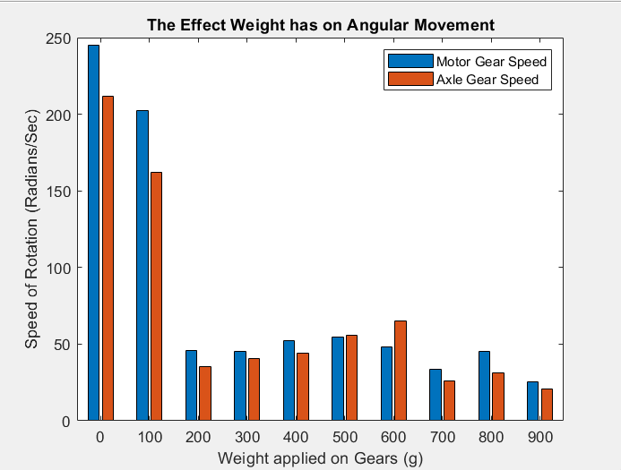

**Conclusion:**

After analyzing the graph, it is clear from our data that the speed of the gears was much faster when there was the least amount of load applied to the system. As more weight was added, there was a drastic decrease in rotational speed of the gears. It can be inferred that in these instances of decreased speed, more torque was required from the motor. We can relate this to our project because it taught us about the importance of weight on our system. The larger the load we put on our system, the more torque will be required, which will in turn require more power to make our system move at the speed we want it to.

Experiment 3-Solar Panel Efficiency:

**Objective**:

~Introduction:

The purpose of this experiment was to determine which solar panel available to us would produce the most power from the light. We will be testing to see which solar panel type will produce the most RPM among the gears when attached to our motor. The solar panels would be serving as the energy source for the system.

~Materials:

* DC supply
* Tachometer
* Digital Multimeter (DMM)
* Alligator Clips
* Breadboard
* Jumper Wires
* 330 Ohm Resistor
* Motor (Nichibo 2310191)
* Reflective Tape
* Motor Rail system
* Clamp
* 4 Gears (2 medium, 1 small, 1 large)
* Gear attachments
* Digital Calipers
* Flood Light
* 5 solar panels (differing in wattage and voltage)

~Procedure: The first step is to gather the needed materials. Connect a 50 tooth gear to the motor. Then, connect the solar panel to the motor and the multimeter. To do that, connect the negative motor wire to the negative solar panel wire. Then connect the positive motor wire to the negative multimeter source. Following that, connect the positive multimeter source to the positive solar panel wire. The next step is to set up a flood light directly above the solar panels approximately 2 ft away. After that, turn on the floodlight and measure the RPM of the gear on the motor and the current with the multimeter. Following the data collection, switch out the solar panel to another. Repeat this process until 5 solar panels have been used for data.

**Data:**

| Solar Panel Trial Number | Solar Panel Voltage (v) | Solar Panel Wattage (w) | RPM | Current (A) | Light Source Power (Fc) |
| --- | --- | --- | --- | --- | --- |
| 1 | 6 | 2.5 | 4414 | 50.2 | 4017 |
| 2 | 5 | 1 | 3333 | 45.9 | 4017 |
| 3 | 18 | 1.5 | 1709 | 35.44 | 4017 |
| 4 | 12 | 3 | 4563 | 49.4 | 4017 |
| 5 | 5 | 2.5 | 3514 | 47.4 | 4017 |

**Code: Gabe,Mena, Muhammad, Trevor**

%data

power_output_panelA = 2.5; % Power output Panel A Watts

power_output_panelB = 1; % Power output Panel B Watts

power_output_panelC = 1.5; % Power output Panel C Watts

power_output_panelD = 3; % Power output Panel D Watts

power_output_panelE = 2.5; % Power output Panel E Watts

motor_rpm_panelA = 4414; % Motor RPM Panel A

motor_rpm_panelB = 3333; % Motor RPM Panel B

motor_rpm_panelC = 1709; % Motor RPM Panel C

motor_rpm_panelD = 4563; % Motor RPM Panel D

motor_rpm_panelE = 3514; % Motor RPM Panel E

%Graph

figure;

plot(power_output_panelA, motor_rpm_panelA, 'o-', 'LineWidth', 2, 'DisplayName', 'Panel A');

hold on;

plot(power_output_panelB, motor_rpm_panelB, 's-', 'LineWidth', 2, 'DisplayName', 'Panel B');

plot(power_output_panelC, motor_rpm_panelC, 's-', 'LineWidth', 2, 'DisplayName', 'Panel C');

plot(power_output_panelD, motor_rpm_panelD, 's-', 'LineWidth', 2, 'DisplayName', 'Panel D');

plot(power_output_panelE, motor_rpm_panelE, 's-', 'LineWidth', 2, 'DisplayName', 'Panel E');

xlabel('Power Output (Watts)');

ylabel('Motor RPM');

title('Comparison of Solar Panels: Power Output vs. Motor RPM');

legend('show');

grid on;

Plot: 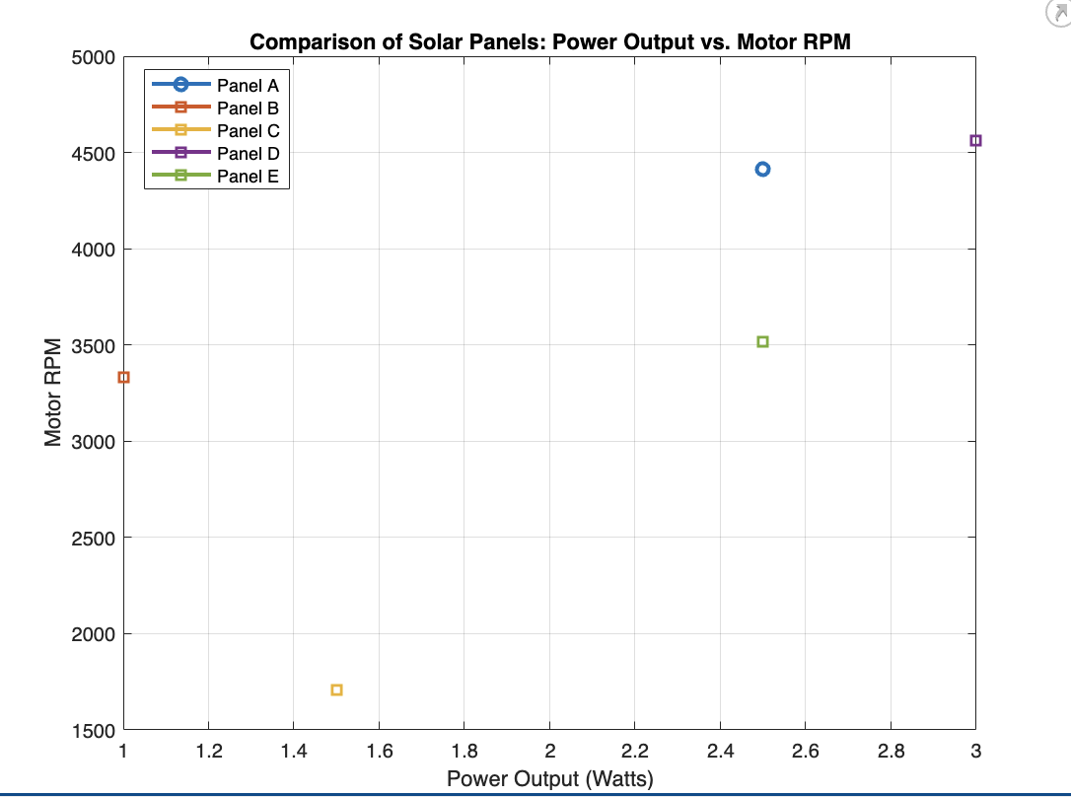

**Conclusion:**

After analyzing the graph and data, it can be concluded that solar panel number 4 allowed the gears to produce the highest RPMs. This also happened to be the solar panel with the second highest voltage and the highest wattage. The data showed that the solar panel with the highest voltage, but the second lowest wattage created the least amount of RPMs from the gears. This shows that a solar panel with a combination of both high voltage AND high wattage is the most efficient. Not one or the other. It can be inferred from this that our solar panel for out project should have high voltage and wattage so that it is the most efficient at transferring power from light into our system. This is handy to know because we now know which solar panel type we should aim to use in our project. The more power from the solar panels, the easier it will be to get the system to carry the load we will create on the motor.